Supply Chain Management (SCM) — NPTEL
Week 11 · Session 2: SC Digital Twin — Green Field Analysis (GFA) with Excel & Any Logistics
1. Recap & Session Scope
- Last session: what is a digital twin — 5 types, 4 enabling technologies, 3 components (visualization + technologies + analytics)
- This session: build a small SC digital twin to perform Green Field Analysis (GFA) — find optimal DC location
- Methods: (1) Excel + Solver for small problem, (2) Any Logistics software for large-scale problems

★ GFA = Green Field Analysis — finding the optimal location for a NEW facility (DC/factory) where none exists yet. It is a prescriptive analytics application of digital twin.

2. Case Study — Pharma Company: DC Location for Western India
Problem Statement
- A pharmaceutical company wants to set up 1 Distribution Center to serve the western region of India
- 4 markets to be served — annual demand and exact coordinates are given
- Objective: find DC location (latitude, longitude) that minimizes total transportation cost

Market Data
Market | Index | Annual Demand (units) | Latitude (xi) | Longitude (yi)
Pune | 1 | 1,57,680 | 18.52 | 73.85
Mumbai | 2 | 1,79,580 | 19.09 | 72.87
Ahmedabad | 3 | 1,55,490 | 23.02 | 72.57
Surat | 4 | 43,800 | 21.18 | 72.83

- Cost assumption: $1 per km per unit of demand transported (can be updated to actual freight rate)
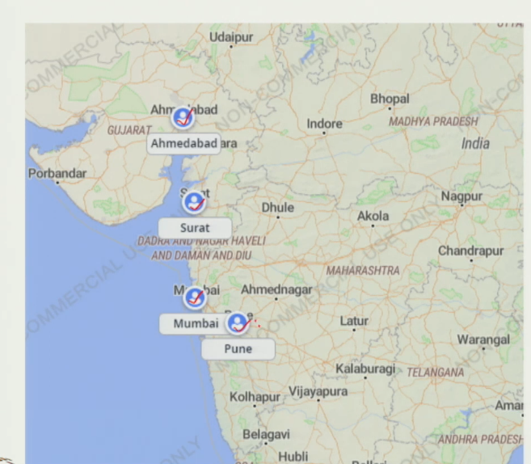
3. Problem Framing — Why Intuition is Insufficient
- Temptation: place DC near Mumbai — highest demand (1,79,580 units)
- But: if DC is near Mumbai, cost to Ahmedabad and Surat increases sharply
- If DC near Pune: cost to Mumbai, Ahmedabad, Surat all increase
- If DC near Ahmedabad: cost to Mumbai, Pune, Surat all increase
- Conclusion: there is a trade-off — need an optimization model to find the true minimum-cost location
- Infinite possible DC locations exist — cannot evaluate manually

4. Optimization Model — Formulation
Notation
- xi, yi = latitude, longitude of market i (known data)
- Demand_i = annual demand at market i (known data)
- xDC, yDC = latitude, longitude of the new DC (decision variables — unknown)
- d(xi,yi → xDC,yDC) = distance from DC to market i (calculated from formula)

Component | Detail
Decision Variables | xDC = latitude of the new distribution center (unknown)  yDC = longitude of the new distribution center (unknown)
Objective: Minimize Z | Z = Σ(i=1 to 4) Demand_i × d(xi,yi → xDC,yDC) × Cost per km per unit  Total transportation cost across all 4 markets from the DC  Cost per km per unit assumed = $1 (can be changed to actual value)
Distance (spherical) | d(xi,yi → xDC,yDC) = Haversine / Spherical formula  Accounts for earth's curved surface — gives accurate km distance
Solver Method | Non-linear optimization — because the distance formula is non-linear (spherical)  Use GRG Non-linear or equivalent non-linear solver in Excel
No. Constraints | No explicit constraints — DC can be placed at any (xDC, yDC) coordinate  Non-negativity of decision variables is implicit (valid lat/long values)

5. Distance Formulas — Three Methods
- Three possible ways to calculate distance between two geographic points:

Method | Formula | Limitation / Use | Accuracy
Direct Line (Euclidean) | √[(xi−xDC)² + (yi−yDC)²] | Straight-line path — not realistic; no turns allowed | Low
Corner (Manhattan) | |xi−xDC| + |yi−yDC| | Accounts for left/right turns — better real-world approximation on flat grids | Medium
Spherical (Earth surface) | Haversine / Spherical trig formula | Accounts for earth's curvature — most accurate for real geographic locations. Used in this case. | High ✓

Why Spherical Formula is Used Here
- Earth's surface is not flat — lat/long are coordinates on a curved surface
- Direct line and corner methods assume a flat plane — give inaccurate distances for geographic locations
- Spherical (Haversine) formula captures earth's curvature → most accurate real-world km distance
- Makes the objective function non-linear → must use non-linear solver (not Simplex LP)
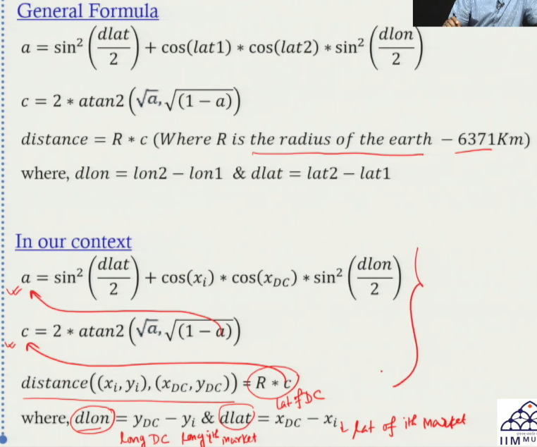
6. Solving in Excel — Step-by-Step
1 | Enter market data | Input demand, latitude, longitude for all 4 markets (Pune, Mumbai, Ahmedabad, Surat)
2 | Set initial DC location | xDC = 20 (latitude), yDC = 72 (longitude) — random starting values; not the answer yet
3 | Calculate distances | Apply spherical distance formula from each DC location to each market → 4 distance values
4 | Calculate individual costs | Cost_i = Demand_i × Distance_i × Cost per km per unit (= $1)
5 | Calculate total cost Z | Z = Sum of all 4 individual costs. At initial (20, 72): Z = 12,44,89,119
6 | Run Solver | Set objective = minimize cell B9 (total cost). Changing variables = B7 (lat), B8 (long). Method = Non-linear. Solve.
7 | Read optimal solution | Optimal xDC = 19.09, yDC = 72.87. Total cost = 9,73,92,135. Location = Mumbai.
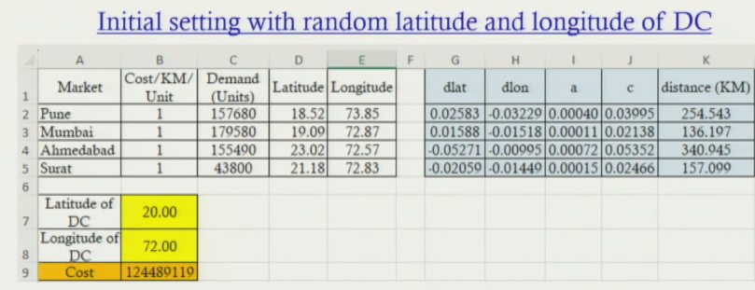
Cost Calculation Example — DC to Pune

Cost (DC → Pune) = 1,57,680 × 254.543 km × $1 = 4,01,59,298
Cost (DC → Mumbai) = 1,79,580 × 136.197 km × $1 = 2,44,58,875
Cost (DC → Ahmedabad) = 1,55,490 × 340.945 km × $1 = 5,29,98,141
Cost (DC → Surat) = 43,800 × 157.099 km × $1 = 68,80,136
Total Z (at initial location 20, 72) = 12,44,89,119

Optimal Solution from Solver
- Optimal DC latitude (xDC): 19.09
- Optimal DC longitude (yDC): 72.87
- Optimal location: coincides exactly with Mumbai
- Minimized total cost Z: 9,73,92,135 (vs 12,44,89,119 at the random starting point)
- Cost saving from optimization: approximately ₹2.7 crore / year

★ The solver tells us: Mumbai is the mathematically optimal location for the DC — weighted by demand and distance, it minimizes total transportation cost across all 4 markets.

7. Digital Twin Visualization — What it Adds
- The Excel model gives the coordinates — but no visual map of the SC
- Digital twin visualization (on a map) adds:
- Exact geographic position of each market plotted using lat/long
- DC location plotted at the optimized coordinates
- Routes from DC to each market shown — visual confirmation of the network
- Immediate intuition about coverage area and travel paths
- This is what tools like Any Logistics provide — map-based visualization + optimization combined

8. Scaling Up — AnyLogistix Software for Large Problems
Why Excel Fails at Scale
- Excel works for 4 markets — but 4,000 or 40,000 markets across India/globe make it impractical
- Manual lat/long entry for thousands of cities is not feasible
- Formula setup, solver configuration, and interpretation become unmanageable

How AnyLogistix Solves This
- Enter city name (e.g., Mumbai) → software auto-retrieves lat/long from its database
- All nodes plotted on actual map automatically after input — no manual plotting
- Built-in optimization algorithm runs automatically — no Solver setup needed
- Result: DC location plotted on map with lat/long + connections to all demand points shown
- Any Logistics result confirmed: GFA optimal DC = lat 19.09, long 72.87 = Mumbai
- Matches Excel Solver output exactly — validates both approaches

Attribute | Excel Solver | Any Logistics (DT software)
Scale | Small (4 markets — manageable manually) | Large (thousands or lakhs of markets — nationwide / global)
Lat/Long input | Must be manually entered for each location | Enter city name → auto-retrieves lat/long from database
Visualization | Basic — no map plotting built in | Plots all nodes on actual map automatically after input
Algorithm | Non-linear Solver (GRG) — user sets it up | Built-in optimization algorithm runs automatically
Result output | Optimal xDC, yDC + total cost (cell values) | Optimal DC location plotted on map + lat/long + connections shown
Speed | Feasible but manual — formula setup required | Click of a button — fully automated for any scale
Typical use | Teaching, small-scale understanding | Real-world SC network design and digital twin development

★ Any Logistics is a digital twin enabler — it automates visualization, optimization, and result display for large-scale SC network design that Excel cannot handle.

9. Digital Twin Framework — Applied to This Example
- Digital Visualization: 4 markets + optimal DC location plotted on geographic map with routes
- Digital Technology: Any Logistics software + optimization algorithm (connects physical SC problem to digital model)
- Prescriptive Analytics: model tells WHERE to locate DC to minimize cost — a direct prescriptive output
- This is a full mini digital twin — not just a visualization, but an analytically driven location decision

Session Summary
- Green Field Analysis (GFA): finding optimal location for a NEW DC using optimization — a prescriptive analytics application
- Case: pharma company, 4 western India markets (Pune, Mumbai, Ahmedabad, Surat), minimize transportation cost
- Model: Minimize Z = Σ(Demand_i × Distance_i × Cost/km/unit). Decision variables: xDC, yDC.
- 3 distance formulas: Direct line (low acc) → Corner/Manhattan (medium) → Spherical/Haversine (high — used here)
- Spherical formula = non-linear → must use non-linear solver (GRG), not Simplex LP
- Excel result: Optimal xDC = 19.09, yDC = 72.87 (Mumbai). Cost = ₹9.73 Cr vs ₹12.44 Cr at random start.
- Any Logistics: same result plotted on map automatically — scales to thousands of markets
- DT components used: Visualization (map) + Technology (Any Logistics) + Prescriptive Analytics (location optimization)

★ Exam Tip: GFA = Green Field Analysis. Objective: minimize Σ(Demand × Distance × Cost). Decision variables: xDC and yDC (lat/long of new DC). No other constraints.
★ Exam Tip: 3 distance methods: (1) Euclidean = straight line, (2) Manhattan/Corner = turns allowed, (3) Spherical/Haversine = accounts for earth's curvature → most accurate → use this for real geo problems.
★ Exam Tip: Spherical distance formula is non-linear → must use NON-LINEAR solver (GRG). Cannot use Simplex LP. Contrast with CPLP (Simplex LP) and CoG (GRG too).
★ Exam Tip: Any Logistics advantage: auto lat/long retrieval by city name, map visualization, built-in optimizer. Excel advantage: understanding the mechanics. Use Excel to learn, Any Logistics to scale.

